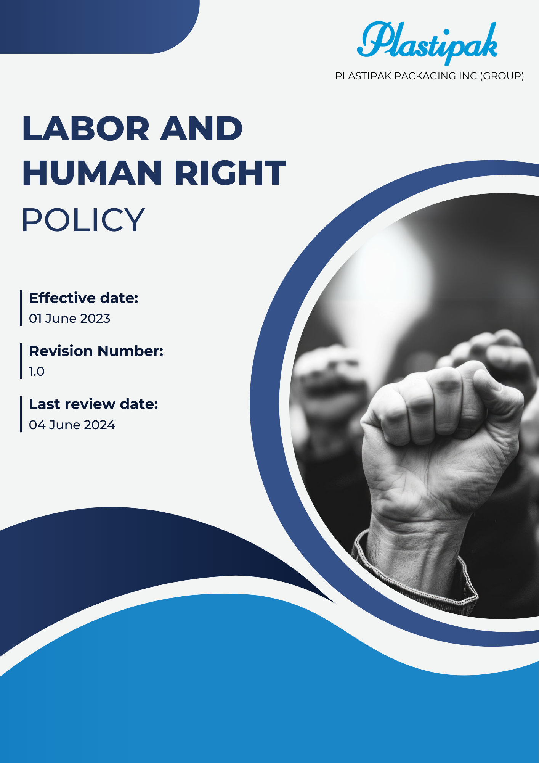

Contents
1.0 Introduction 3
2.0 Objectives 3
3.0 Applicability 3
4.0 Key focus areas 3
5.0 Key Commitments to Labor Rights and Human Dignity 6
6.0 Performance Metrics for Social Sustainability Goals 8
7.0 Reporting and Accountability 10
8.0 Responsibility 11
9.0 Governance 13
10.0 Continuous Improvement 13
11.0 Review Mechanism 14
12.0 Employee acknowledgement form 15

Labor and Human Right Policy

Introduction
- At Plastipak Packaging Inc. (Group), we are committed to maintaining exemplary standards of labor and human rights throughout our global operations. This Labor and Human Rights Policy highlights our dedication to fair labor practices, the respect for human dignity, and the promotion of diversity and inclusion. We strive to cultivate a workplace that is safe, respectful, and equitable for all employees and stakeholders, while ensuring compliance with relevant laws and international human rights principles.

Objectives
- Fair Employment Practices: We are dedicated to treating all employees with fairness and respect, ensuring their rights to freely choose their employment, receive fair compensation, and work in safe conditions. We firmly prohibit forced labor, child labor, and all forms of discrimination.
- Diversity and Inclusion: We aim to create a diverse workforce and nurture an inclusive workplace culture that appreciates and respects individuals from varied backgrounds. Our goal is to eliminate biases in hiring, promotions, and development opportunities, ensuring that all employees have equal access to advancement.
- Employee Health and Safety: We prioritize the health, safety, and well-being of our workforce by implementing thorough health and safety initiatives, providing access to mental health support, and promoting a healthy work-life balance. Our aim is to foster an environment where employees feel safe, supported, and empowered to express their concerns.

Applicability
- This policy applies to all Plastipak employees, contractors, third-party partners, and internal and external stakeholders, including customers directly or indirectly associated with Plastipak. It encompasses all offices, headquarters, facilities, and operational sites where Plastipak provides packaging solutions, recycled materials, and transportation services. This policy ensures that respect for labor rights, human rights, and fair working conditions are integral to our operations worldwide, promoting ethical practices across the organization.

Key focus areas
  - Employee Well-being and Safety
- We are committed to prioritizing the health and safety of our workforce by implementing comprehensive programs that promote a safe and healthy work environment.
- Our focus includes establishing rigorous safety protocols and conducting regular training sessions to enhance employee awareness.
- We provide access to essential health resources to prevent workplace injuries and illnesses.
- Our objective is to foster a culture of safety where every employee feels empowered to raise concerns and contribute to safety initiatives.
  - Workplace Environment
- We are dedicated to creating positive and equitable working conditions that enable all employees to thrive.
- This involves ensuring proper ergonomics and providing access to necessary resources for all staff.
- We maintain open lines of communication to effectively address workplace issues as they arise.
- Regular assessments and enhancements to our facilities will improve the overall employee experience and promote productivity.
  - Prohibition of Child Labor, Forced Labor, and Human Trafficking
- We categorically reject child labor, forced labor, and human trafficking in all forms within our operations and supply chain.
- Our policy mandates strict adherence to local and international labor laws to uphold human rights standards.
- We implement proactive measures to prevent violations and ensure ethical practices within our supply chain.
- Conducting thorough audits of our suppliers allows us to ensure alignment with our commitment to ethical labor practices.
  - Labor Relations
- We strive to cultivate positive labor relations through constructive dialogue between management and employees.
- Our commitment includes respecting workers' rights to freely associate and engage in collective bargaining without interference.
- We prioritize transparent communication and actively collaborate with labor representatives to resolve issues.
- This approach enables us to effectively address concerns and enhance workplace relations.
  - Diversity, Equality, and Inclusion
- We are devoted to fostering a diverse and inclusive workplace where every individual is treated fairly and with respect.
- Our initiatives actively promote equal opportunities for all employees, regardless of their background.
- We engage in diversity training and awareness campaigns to support our objectives for inclusivity.
- Targeted recruitment efforts help us create a workforce that reflects the diverse communities we serve.
  - Human Rights in External Stakeholder Engagement
- We acknowledge the importance of respecting human rights within our organization and among external stakeholders.
- Our policy ensures that suppliers and partners uphold the same human rights standards that we maintain.
- We aim to conduct due diligence to assess and mitigate human rights risks throughout our supply chain.
- This commitment promotes responsible business practices across all levels of engagement with external parties.
  - Career Management and Development
- We are focused on supporting our employees' career management by providing robust opportunities for growth and development.
- Access to training programs and mentorship initiatives are essential components of our policy.
- We aim to establish clear pathways for advancement within the organization to encourage employee progression.
- By nurturing talent, we strive to foster an environment where employees can achieve their professional goals and contribute to our collective success.

Key Commitments to Labor Rights and Human Dignity
- Employee Well-being and Safety
- We aim to strengthen workplace safety by adopting the Human and Organizational Performance (HOP) approach, focusing on improving systems, behaviors, and processes to reduce risks and enhance employee well-being across all operations.
- We aim to create a proactive health and safety culture by conducting regular training sessions and workshops that empower employees with knowledge and skills.
- Our goal is to maintain a zero-accident workplace by implementing strict safety protocols and conducting frequent safety audits across all facilities.
- We strive to enhance mental health support services, ensuring all employees have access to resources that promote psychological well-being and resilience.
- Regular health assessments will be conducted to identify and address potential risks, ensuring a safe working environment for everyone involved.
- Workplace Environment
- We are committed to fostering an inclusive and positive work environment that emphasizes respect, support, work-life balance, and the right to disconnect.
- We aim to provide a comprehensive benefits package that helps our associates and their families be well—physically, mentally and financially.
- Clean and well-organized workspaces are a priority, with plans to uphold high standards of hygiene while offering fair compensation and comprehensive social benefits.
- To eliminate workplace harassment and discrimination, we will introduce initiatives promoting inclusivity and conduct regular employee satisfaction surveys to address concerns.
- Mutual respect will be nurtured through team-building activities, open communication channels, and programs focused on employee well-being and maintaining a healthy work-life balance.
- Our approach includes the continuous evaluation and improvement of workplace practices, ensuring fair pay, social benefits, and the right to disconnect for a safe and productive environment.

- Prohibition of Child Labor, Forced Labor, and Human Trafficking
- We are dedicated to ensuring that our operations are free from child labor, forced labor, and human trafficking through rigorous supplier assessments and audits.
- Our objective is to implement a comprehensive reporting mechanism that allows employees and stakeholders to report any suspected violations confidentially.
- We strive to educate our suppliers on ethical labor practices, ensuring they understand our zero-tolerance policy towards exploitation in all forms.
- Ongoing partnerships with NGOs will enhance our capability to identify and address potential human rights violations within our supply chain.
- Labor Relations
- We aim to foster a collaborative labor environment by facilitating open dialogue between management and employees, ensuring all voices are heard and respected.
- Our goal is to resolve disputes promptly and effectively, maintaining a harmonious workplace and positive relationships with labor representatives.
- We strive to provide training for managers on effective communication and conflict resolution strategies to strengthen labor relations across all levels.
- Regular engagement surveys will be conducted to gauge employee satisfaction and identify areas for improvement in labor relations practices.
- Diversity, Equality, and Inclusion
- As an active corporate member of the Women in Manufacturing (WiM) Association, we provide our female associates worldwide access to the organization’s networking events, fostering professional growth and leadership development.
- We are dedicated to cultivating a diverse and inclusive culture where every employee feels welcomed, respected, and valued.
- Our commitment includes ongoing reviews and improvements to address disparities and better support diverse and underrepresented groups across the organization.
- We aim to provide comprehensive training to promote awareness, respect for different perspectives, and a collaborative, inclusive work environment.
- Establishing measurable goals will help us ensure continuous progress and demonstrate our strong dedication to diversity, equity, and inclusion.
- Embedding DEI principles into all areas of operation is essential to fostering an equitable and culturally rich environment for everyone.
- Human Rights in External Stakeholder Engagement
- We strive to respect and promote human rights in all interactions with external stakeholders, ensuring transparency and accountability in our operations.
- Our objective is to conduct regular human rights assessments to identify potential impacts and engage with affected communities proactively.
- We aim to develop partnerships with local organizations to support human rights initiatives and contribute positively to community well-being.
- Regular training will be provided for employees on human rights issues, ensuring awareness and adherence to best practices in stakeholder interactions.
- Career Management and Development
- We are committed to providing robust career development opportunities, ensuring all employees have access to resources that support their growth and advancement.
- Our goal is to implement mentorship programs that connect employees with leaders within the organization, fostering personal and professional development.
- We strive to offer regular training sessions focused on skill enhancement and career progression to empower employees in their career paths.
- Annual performance reviews will be utilized to identify development needs and create individualized career plans that align with employee aspirations and organizational goals.

Performance Metrics for Social Sustainability Goals
- Employee Well-being and Safety
- We aim to reduce misses/observations on health and safety reported globally by 2026 from the baseline 2022.
- We aim to reduce workplace injuries and accidents by 50% by 2025, compared to the figures from 2022.
- We aim to conduct health and safety risk assessments at 100% of operating sites by 2025, using 2022 as the baseline.
- We strive to increase employee participation in safety training programs to 100% by 2025, with a 75% participation rate in 2022.
- We plan to reduce absenteeism due to work-related health issues by 30% by 2025, using data from 2022.
- We aim for 75% employee engagement in mental health programs by 2025, from the baseline 2022.
- Workplace Environment
- We aim to increase employee satisfaction related to working conditions by 20% by 2025, with baseline year 2022.
- We aim to cover 100% of employees in health care plan by 2025 from the baseline 2022.
- We target 100% compliance with safety standards by 2025, with baseline year 2022.
- We will implement flexible work arrangements for 60% of eligible employees by 2025, with baseline year 2022.
- We plan to conduct annual working conditions audits at all sites by 2025, with baseline year 2022.
- Prohibition of Child Labor, Forced Labor, and Human Trafficking
- We aim to achieve 100% supplier compliance with labor policies by 2025, with baseline year 2022.
- We will conduct human rights assessments across 100% of supply chain partners by 2025, with baseline year 2022.
- We strive to increase labor audits by 50% by 2025, with baseline year 2022.
- We plan to provide 100% of key employees with human rights training by 2025, with baseline year 2022.
- Labor Relations
- We aim to increase union participation by 25% by 2025, with baseline year 2022.
- We strive to resolve 90% of labor disputes within 30 days by 2025, with baseline year 2022.
- We plan to conduct annual labor relations surveys, targeting a 20% improvement in positive feedback by 2025, with baseline year 2022.
- We will ensure 100% compliance with labor standards by 2025, with baseline year 2022.

- Diversity, Equality, and Inclusion
- We aim to increase the representation of underrepresented groups in leadership roles by 30% by 2025, with baseline year 2022.
- We target 100% participation in diversity, discrimination and harassment training by 2025, with baseline year 2022.
- We strive to eliminate the gender pay gap by 2025, with baseline year 2022.
- We plan to ensure that 40% of new hires come from diverse backgrounds by 2025, with baseline year 2022.
- Human Rights in External Stakeholder Engagement
- We aim to increase stakeholder engagement on human rights by 30% by 2025, with baseline year 2022.
- We target 100% implementation of human rights assessments for key partners by 2025, with baseline year 2022.
- We will publish annual human rights reports with full transparency by 2025, with baseline year 2022.
- We strive to reduce identified human rights risks by 40% by 2025, with baseline year 2022.
- Career Management and Development
- We aim to increase employee participation in career development programs by 35% by 2025, with baseline year 2022.
- We target 100% of employees with individual development plans by 2025, with baseline year 2022.
- We strive to improve internal promotion rates by 20% by 2025, with baseline year 2022.
- We plan to ensure that 70% of employees receive annual performance reviews by 2025, with baseline year 2022.

Reporting and Accountability
- Performance Reports
- We will compile annual reports detailing our performance in labor and human rights, tracking progress against key metrics such as employee well-being, diversity, and workplace safety.
- These reports will be disseminated to stakeholders—including employees, clients, suppliers, and investors—to uphold transparency and accountability.
- Internal Audits and Compliance Checks
- Regular internal audits will be conducted to ensure adherence to labor laws, company policies, and operational objectives.
- Findings from these audits will be reviewed by senior management, and corrective actions will be promptly taken to rectify any identified shortcomings.
- Stakeholder Engagement and Feedback Mechanism
- We will actively involve stakeholders through surveys, consultations, and meetings to collect their insights on our labor practices and identify potential areas for enhancement.
- Partnering with stakeholders will help us stay aligned with current labor trends and industry standards.
- Grievance Mechanism
- A dedicated platform will be established to enable employees, clients, and external parties to confidentially report labor-related concerns without fear of retaliation.
- All grievances will be investigated thoroughly, and appropriate measures will be taken to address the issues raised.
- Public Disclosure
- We will publicly share essential labor metrics, achievements, and challenges on an annual basis through sustainability reports or designated sections on our website.
- This commitment to transparency underscores our dedication to labor rights and accountability to all stakeholders.

Responsibility
- Executive Leadership
- Champion the Labor and Human Rights Policy at the highest level
- Allocate necessary resources for policy implementation
- Review and approve strategic initiatives and performance targets

- Chief Human Rights Officer
- Oversee the global implementation of the Labor and Human Rights Policy
- Develop strategic plans to advance the company's human rights objectives
- Serve as the primary liaison with external stakeholders on human rights matters
- Facility Managers
- Facility and operations managers will implement sustainable labor practices in everyday operations, focusing on workplace safety, employee engagement, and diversity.
- They will ensure compliance with local labor standards and monitor the labor conditions at the facility level.
- Any labor incidents or compliance issues will be reported to the Labor Compliance Officer.
- Support for employee engagement initiatives, including diversity and inclusion programs, will be a priority.
- Procurement / Supply Chain Managers
- Procurement and supply chain managers will ensure that suppliers comply with labor standards and promote ethical labor practices throughout the supply chain.
- They will prioritize sourcing materials from suppliers that adhere to fair labor practices and ethical guidelines.
- Human Resources (HR)
- HR will lead awareness campaigns and training on labor practices and human rights initiatives.
- Integration of labor responsibilities into employee performance evaluations and appraisal systems will be emphasized.
- HR will encourage employee involvement in labor initiatives, including diversity programs and workplace safety efforts.
- Employees
- Employees are expected to adhere to the labor practices and guidelines outlined in the Labor and Human Rights Policy.
- Participation in labor initiatives, such as diversity and safety programs, is encouraged.
- Employees should report any labor-related concerns or compliance issues through the designated grievance mechanism.
- Contractors and Third-Party Partners
- Contractors and third-party partners must comply with the labor standards and practices outlined by the company.
- Support for the company’s labor goals through responsible operational practices is essential.
- Collaboration with relevant teams will be necessary to ensure proper labor management and ethical supply chain practices.

Governance
  - Governance of this policy ensures accountability at all levels, with the Board of Directors providing strategic oversight and establishing labor goals. Senior leadership integrates labor rights into operations and monitors performance, while the Labor Compliance Officer ensures regulatory compliance and reports progress. Department heads implement practices within their areas, driving workplace safety and employee engagement. Employees and contractors actively contribute to labor initiatives and report on improvements. Suppliers and partners collaborate to meet labor targets and uphold ethical practices. Regular audits, stakeholder engagement, and transparent reporting will facilitate continuous improvement and alignment with evolving labor standards.

Continuous Improvement
  - We are dedicated to continually improving our labor practices by establishing measurable goals, tracking progress, and identifying areas for enhancement. Regular internal audits, performance evaluations, and stakeholder feedback will help ensure our practices remain effective and in line with emerging labor standards. Additionally, we will benchmark against industry best practices to drive innovation and strengthen our labor initiatives.
  - This policy will be reviewed annually to adapt to changing regulations, technological advancements, and labor trends. Training programs and awareness initiatives will foster a culture of respect for labor rights among employees, empowering them to contribute to our labor objectives. Through collaboration with partners and suppliers, we aim to develop new solutions that enhance workplace fairness, promote safety, and uphold human rights throughout our value chain.

Review Mechanism
- HR Head will perform an annual review of this policy to evaluate its effectiveness and relevance. This process will include assessing compliance with labor regulations, analysing performance metrics, and identifying improvement opportunities. Recommendations will be documented and presented to management for consideration and action.

Prepared by: HR Head Approved by: Managing Director
Next Review Date: 02 / 06 / 2025

Employee acknowledgement form
I, the undersigned, acknowledge that I have received, read, and understood the Labor and Human Rights Policy of Plastipak packaging Inc (Group). I recognize my responsibilities in adhering to the guidelines outlined in this policy and commit to contributing to our organization’s efforts in promoting labor rights and human dignity. I understand that it is my duty to report any violations or concerns regarding labor compliance to my supervisor or the Labor Compliance Officer. I also acknowledge that this policy may be updated and that I will be informed of any significant changes. I appreciate the company’s commitment to labor rights and recognize the importance of my role in fostering a respectful and equitable work environment. I am aware that my actions can impact my colleagues and the workplace, and I will strive to implement ethical labor practices in my daily responsibilities.

Employee Name: ____________________
Employee Signature: ________________
Date: _____________________________

